**CHAPTER 1**

**1.INTRODUCTION**

Registration and tracking system A learning management system, or LMS, is more commonly referred to as system software. Companies utilise it to offer online learning to their employees, and it guarantees quick implementation, high-quality training delivery, and simplicity of use. Registration and tracking It enables you to upload or develop eLearning courses, allocate training materials to specific workers or teams of workers, and monitor learner progress. Consider checking out some of the training software solutions described below if you need to up-skill your workforce. Your workload will be reduced, and you'll have more time, which will improve staff performance.

Registration and track system also has some problems by using the software the administration can set up all the courses to their trainers to complete within time course duration is scheduled here registration and tracking software will automatically track their progress.

* 1. **PROJECT DESCRIPTION**

A learning management system, or LMS, is the most common name for employee training management software. Companies utilise it to offer online learning to their employees, and it guarantees quick implementation, high-quality training delivery, and simplicity of use. Software for employee training enables you to design or upload eLearning courses, assign training materials to specific employees or groups of employees, and monitor learners' progress. Therefore, have a look at some of the training software solutions described below if you need to up skill your staff. Your workload will be reduced, and you'll save time, which will improve staff performance. which raise the person's awareness level. Boost a person's proficiency in one or more of their areas of specialisation. Increase an individual’s motivation to perform their job well.

**1.login for the admin** – which is having the full authority for example like view the data of the trainer as well as the students ,creating the batch for the particular trainer and students.

**2.login for student**-Whenever the student login the student is directed to the student login page in which student have authority to have change the password and view the course as well as the topic which have ben covered

**3.trainer-sign-**whenever the trainer sign in the trainer directly send into trainer header form in which trainer can perform the multiple task such as he can change the password as well as he can give the attendance of the particular student who were attended to the particular class . So there are many more options are presents like creating session, selecting the topics, creating the batch these are all handled by the main admin

The project contains the different types of the modules in the projects because as earlier we can see that there are many problems facing by the institute because in the particular institute there are n numbers of students get enrolled and different types of trainers are also situated from different fields of study therefore to keep record of the particular they made this software to keep the record of the each and every student and trainer as well as different collages and after the trainer and student allotted to particular course then the batch is created. For the particular students. For this project we have used the different programming language that is python as we know that python is the high-level programming language which is used to write the programme for the building of the applications like web-development, Machine Learning. so we have used the django frame work because as we know django is the one the most used frame work across the globe because this frame work is very easy to use and understand in the dajngo frame work there is 3 main files which are very much important in the part of python and dajngo development.

**1.Template file**- this file which is very much important for storing the file like html,css,python,javascript and many others. This template file known as skeleton of the particular project.

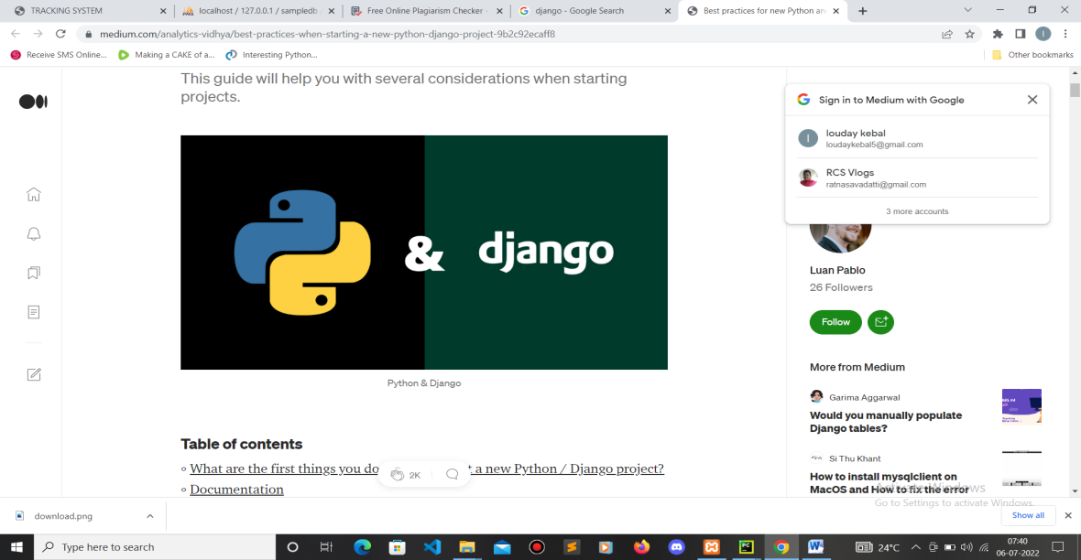

**2.Views file**- This is file which is very much important for writing the logic part for the programme because to some of the work in project like view the table, delete the records, for this all operations we need to write the logic part for this we need the views part to execute the programme.

**3.models file**- This is the very important file for configuration of the data base and the number of tables present in your projects.

**CHAPTER 2**

**2. LITERATURE SURVEY**

**2.1 EXISTING AND PROPOSED SYSTEM**

**Existing System:-**

* Most staff training programmes have a tracking feature. It can be difficult for businesses with a sizable, widely dispersed workforce to keep track of employee training.
* Tracking Classroom-Based Sessions
* Tracking eLearning
* Tracking Assessment Results
* Knowing Sticking Points In Courses
* Knowing Sticking Points In Courses
* Knowing The Date Training Was Completed
* Maintaining the attendance of the students in the paper filing
* Maintaing the different collage information in the filing system

**2.2 PROPOSED SYSTEM:**

Advantages:

1. Easily Assign Staff Members To The Training

2. See Who Has Completed Which Training

3. Keep Track Of When Training Needs To Be Redone

4. Have A Clear On boarding Plan Set Up For New Staff

5. Students can view the topics covered in training

6. Students get day-to-day update regarding training sections

7. Trainer and students can I have a good interaction and communication

8.Students can easily know about trainers

9.Students can know the attendance

10.Tainer can put the attendance of the children

11.student can watch the video related to the course whenever they miss the class.

12.A perfect batch is created for the particular course enrolled by the students.

**2.3 FEASIBILITY STUDY**

The feasibility study aids in determining the proposed system will be helpful for the organization or not. It also checks whether the proposes system will meets user requirements or not. There are three parts in feasibility study as follows.

* Technical Feasibility.
* Operational Feasibility.
* Economical Feasiblity.

Technical Feasibility

* The technical problem of the project will comes in the phase of feasibility study.
* Whether the required technology is exist to perform proposed task?
* Whether the system will be upgraded in future?
* Are there any technical guarantee of correctness, dependability, and information safety?
* Whether the projected tools have the capability to gather the mandatory data to build the system?

Operational Feasibility

* Projected systems are helpful only when they are built as software system. The following are some of key problems come to check the viability of the operation.
* Is there any sustain for the organization from the customer?
* Once the system is developed and implemented, will system work correctly?
* The system is to be in agreement with the above declared problems. Earlier, the administration problem and customer necessities have been considered.
* The fine-structured design would make sure the finest utilization of the computer resources.

Economic Feasibility

The development price in forming the system is estimated in opposition to the profit derivative from the new system. Economical profit must equivalent or goes over the expenses. The system is economically feasible. It does not need any extra H/W or S/W.

**2.4 TOOLS AND TECHNOLOGIES USED**

**Xampp Server:**

The Apache HTTP Server, MariaDB database, its a free and open-source cross-platform web server solution stack bundle created by Apache Friends.

Before releasing a website to the primary server, xamp is an another best platform to prvide the servere which is very useful to run the application which we have build for the particular project. Xammp consisting of the localhost which runs on the particular ip address and it also provides n number of coloumns and n number of rows to store the data in the data base.

**MySQL:**

It is data base sever that allows user to feed and fetch the structured data as per requirements.

The word "My" is a combination of "SQL," the acronym for structured query language, and "My," the name of co-founder Michael Widenius's daughter.

It enables you to keep track of all of your blog posts, users, plugin data, etc. It is relational because it saves such data in several "tables" and links it with "keys."

**Java scripit**

In our project we use the java script for to make the project more interactive and reliable .for the html and css are the considered as the full body but java script is the mechansiam which is undergoing in the website is handeled by the java scrit .

Now a days we can see that java script is the one the most used language all over the world which make complicated work more simplar and understandable.

**HTML:**

Marking up in hypertext Language is a fundamental language that is used to create web pages and is easily understood by all browsers.

The html is also known as the skeleton part of the paroject because without any html we cannot build the application .html is one of the largest used language around the globe.technologies like css (cascading style sheet) and java script are supported by this language. In our project html and css also javascript plays an important role because for the login page and admin pages we use html css for designing the template because to understand the project and make it more interstable for the viewers , HTML offers a way to generate structured texts. Tags, which are written in angle brackets, are used to distinguish HTML elements.

Input and image tags, for example, add content directly to the page. Other tags, like p>, enclose and describe the text of the document. They may also contain other tags as sub-elements. Browsers employ the HTML tags to decipher the page's content rather than displaying them.

**CSS:**

* Cascading Style Sheets are used to format the page's content and improve the appearance of web pages.
* Cascading Style Sheets, or CSS

CSS saves a lot of labour by describing how html elements should be rendered on screens, paper, or in the other media. Multiple web pages' layouts can be managed simultaneously using it.

External style sheets are kept in CSS files.

Css is used to make the design for the particular website in our case we use css for the project to become more interactive to the user.

**Django:**

A free and open-source web framework built on Python called Django uses the model-view-template design principle. The Django Software Foundation, an independent company registered as a 501 non-profit, looks after it .django is primry used to make the easy to data base system.

• The framework places an emphasis on reusable and "pluggable" components, fewer code, less coupling, quick development, and the don't repeat yourself philosophy.

• Python is utilised everywhere, including in the data models and settings files.

• In addition, Django offers a customizable administrative creation, read, update, and delete interface that is produced dynamically by introspection.

• The Django framework can be thought of as an MVC structure.

• It comprises of an object-relational mapper (ORM) that acts as a middleman between relational databases and data models, which are represented by Python classes ("Model").

• An HTTP request processing system featuring a regular expression-based URL dispatcher and a web templating system ("View") ("Controller").

• PostgreSQL, MySQL, SQLite, and Oracle are the four database backends that Django formally supports.

• On Microsoft operating systems, django-mssql can be used with Microsoft SQL Server,

• There are comparable external backends for FireBird, SQL Anywhere, and IBM Db2.

• Django-nonrel is a fork that supports NoSQL databases like MongoDB and Google App Engine's Datastore.

**Python:**

In our project we have used the main language is python because it is one the most easily understandable language over the world. Python is compiled language which is normaly used for webdesigns,artificial intillegence,machine learning. In our project we have many tables and modules based on the admin so understand easy I have used the python language.

**2.5 HARDWARE AND SOFTWARE REQUIREMENTS**

Hardware Requirements:

|  |  |
| --- | --- |
| CPU | Pentium |
| Speed | 1.1Ghz |
| RAM | 1GB |
| Hard Disk | 20GB |

Software Requirements:

|  |  |
| --- | --- |
| Language | Python |
| Database | MySQL |
| Operating System | Windows XP or Above |
| Front end | Html,css |
| Back end | MySQL |
| Middleware | django |
| Server | Xampp |

**CHAPTER 3**

**3.SOFTWARE REQUIREMENT SPECIFICATION**

It describes the operation of the system and the boundaries on those operations. Are mentioned below :

**3.1 USERS**

Need to build application which is simple and easy, so that it should meets the user requirements. It consists of following models.

* Admin
* Trainer
* Student

**Admin:**

* Sign in
* Register and view Trainer
* Create and view Course
* Create and view Sessions
* Register and view College
* Create and view Batch

**Trainer:**

* Sign_in
* Track Student
* Give Attendance of student

**Student:**

* Sign _in
* Sign _up
* View course

**3.2 FUNCTIONAL REQUIREMENTS**

The services that a system offers and which are accepted in accordance with user requirements are described in the functional requirement of a system. It depends on the kind of application that is created. The system's functionality is thoroughly described in the functional requirements.

There is 3 main function requriments in the particular system

**1.admin**

The admin is the main member which is used to control and coordinate the system he or she perform the role like adding the student,maintaining the students, adding the course ,creating the batches and so on.

**2.teacher**

Teacher used to teach the student of which they have enrolled for giving the attendance updating the topic is done by the teacher

**3.students**

Students are the important part of this model to enrol the course and in case of the students, students can view the course and select the course they want.

**3.3 NON-FUNCTIONAL REQUIREMENTS**

The main intention of this step is to preserve quality of the system.

The following are some non-functional requirements.

Specification of the quality-related factors:

This was done to identify the elements that influence system quality.

* **Correctness:** The degree to which a software complies with system requirements.
* **Realibility:** The extent to which a programme complies with system requirements
* **Efficiency:** The total amount of computer resources needed for a software to complete a task.
* **Usability:** The time and effort needed to operate the system.
* **Maintainability:** The simplicity with which programme mistakes can be found and fixed. Testability is the amount of work necessary to test a programme to assure proper operation.
* **Portability:** The simplicity with which a programme can be moved from one H/W configuration to another.
* **Accuracy:** The desired level of accuracy in computation, editing, and output.

**CHAPTER 4**

**4. SYSTEM DESIGN**

If the design of the product is good then the interaction of the system is also good. It is helpful to make a working model.

**4.1 SYSTEM PERSPECTIVE**

The whole system fig helps to resolve which all the outside effects communicating with the system. It shows in what way the information if exchanging.

* To store the data in the safer hand
* Keeping the important information of students
* Monitoring of the academic use
* Providing access to all teachers for attendance

**4.2 CONTEXT DIAGRAM**

It indicates how outside things are interacting with the admin. In the below fig the trainer and student, requests to the admin for their respective tasks.

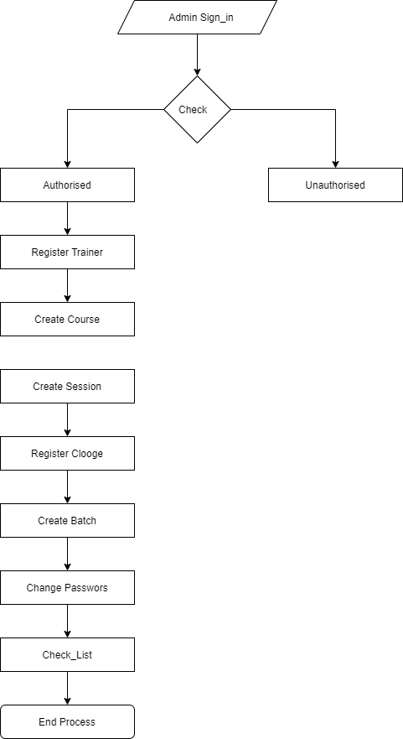

Fig 4.2.1 Context Diagram of Admin.

**Trainer Sign_in Context Daigram:**

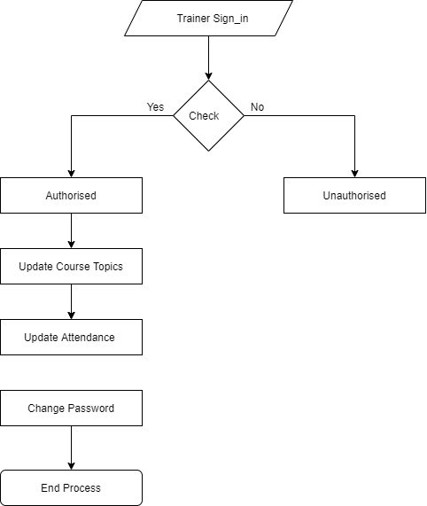

Fig 4.2.2 Trainer Sign-in Context Diagram

**Student Sign_in Context Daigram**

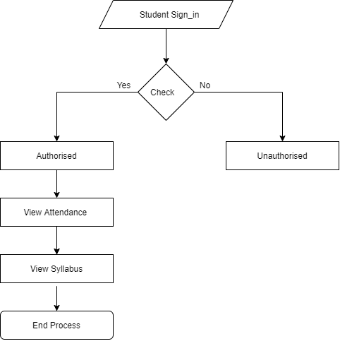

Fig 4.2.3 Student sign-in Context Digram

**CHAPTER 5**

**5. DETAILED DESIGN**

Detailed design helps to know the interface. To make a good system, the design should be implemented. is the stage where plans, specs, and estimates are made as well as the design is refined. Finishing the product's design is required.Symbols of Use Case Daigram

Actor

Use Case

<<include>> Relationships

<<extend>>

**5.1.2 Use Case Daigram**

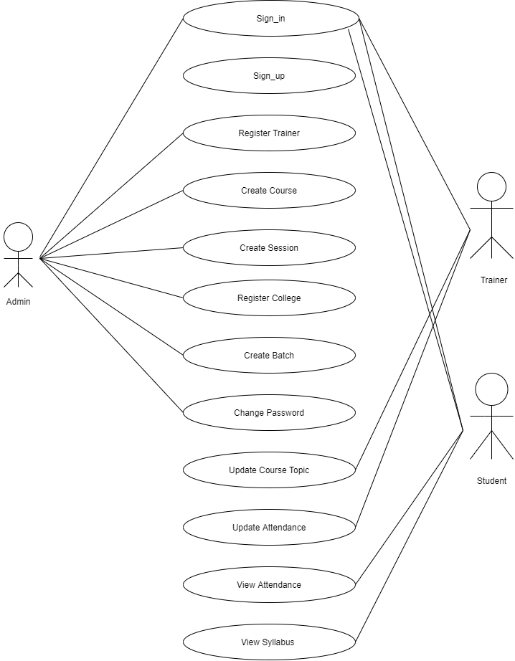

**5.2 SEQUENCE DAIGRAM**

A sequence diagram is created using undefined modelling language, that show the way of message sent and received by the object during the an particular interactions. It tells what the message exchange between the different or same items in a given time. The following figure shows about the message exchanged between admin, trainer and student. 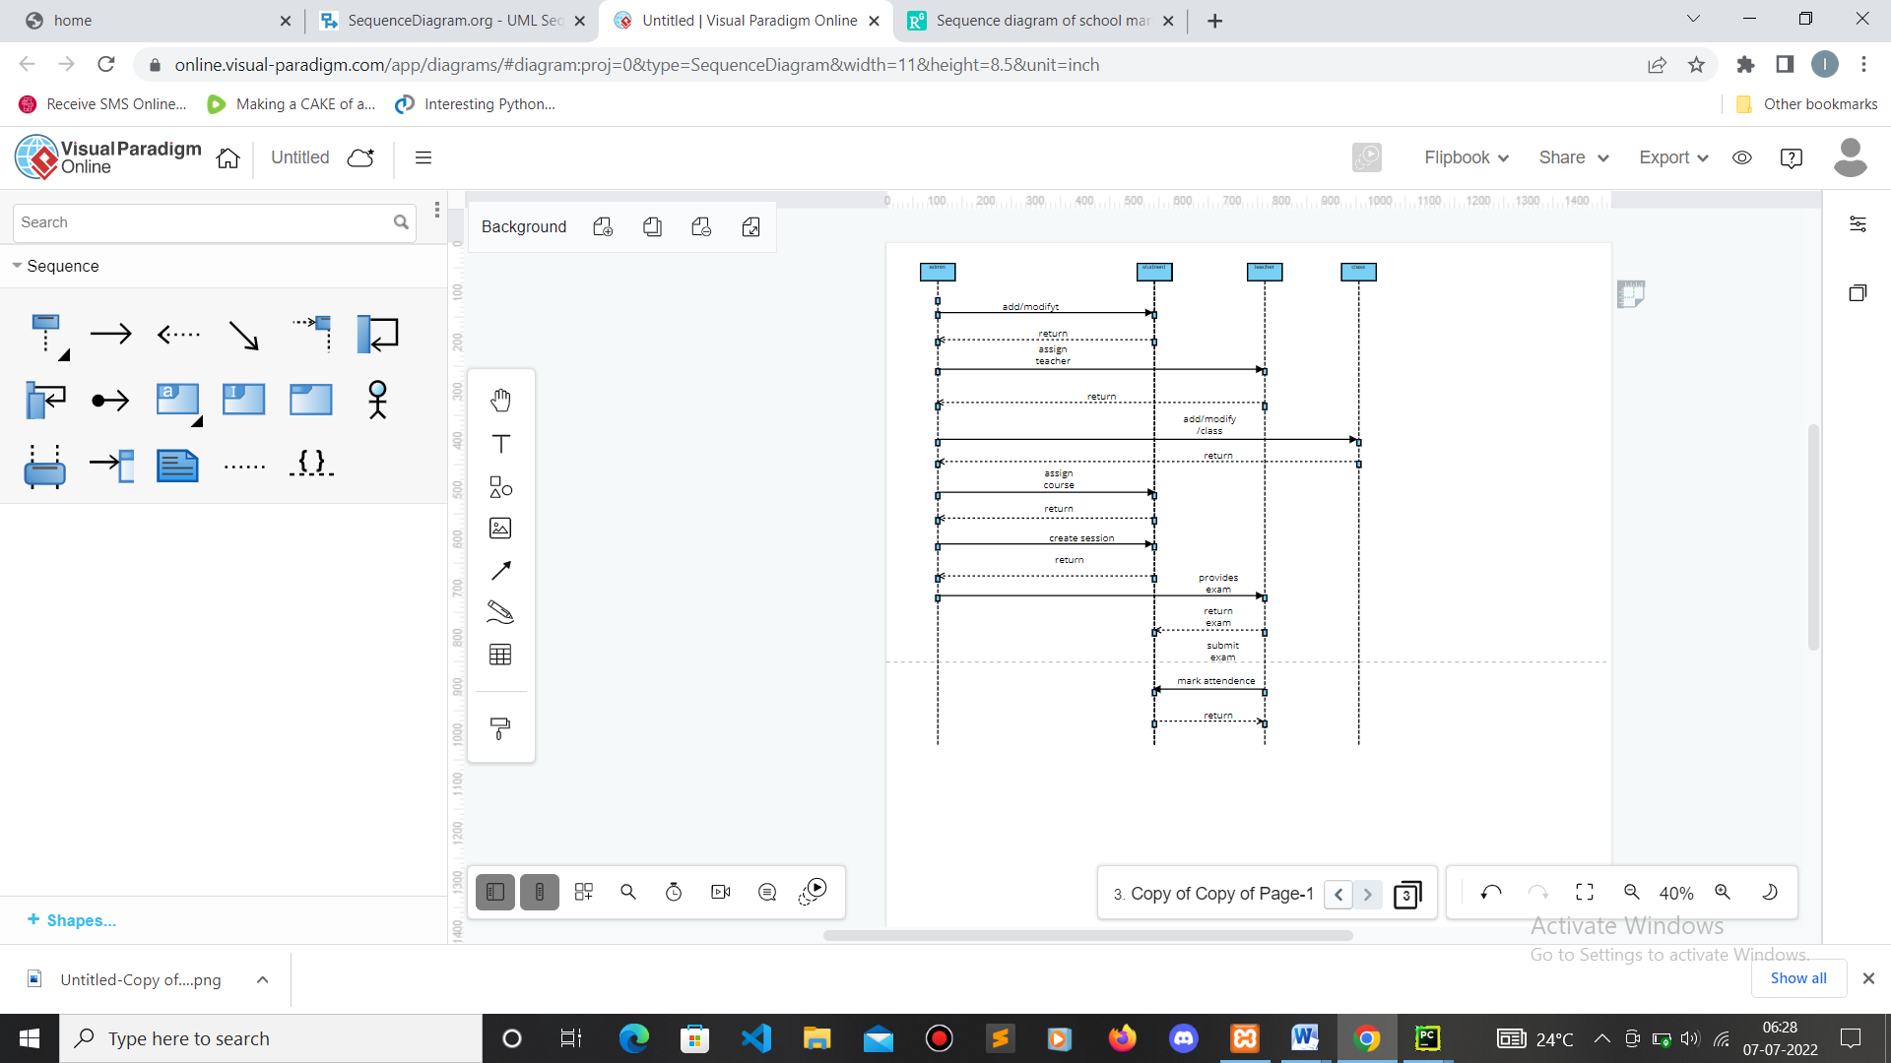

**5.3 COLLABORATION DAIGRAM**

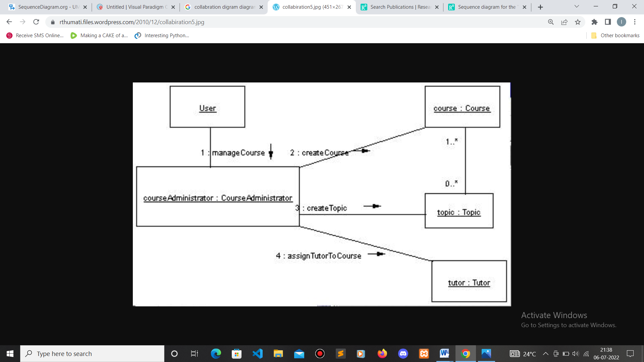

In the above figure we can see it is colabration digarm showing the user methods for example managing the course and topic and managing the trainer to the batch and assigning the students to the batch.

**5.4 ACTIVITY DAIGRAM**

It shows control flow. The below figs shows the control flows for Admin, Trainer and Student.

Sign_in

no

View students

Register College

Change Password

Create Batch

Create Session

Create Course

Register Trainer

TRTra

Logout

5.4.1 Admin Activity Daigram

The above diagram represent the admin module in which admin can perform many tasks like student view,registration,creating batch,and many more.

Sign_in

no

View students

TRTra

Update Attendance

Update Course

TRTra

Logout

Fig5.4.2 Trainer Activity Daigram

In the above figure it is the trainer module in which whenever trainer registor he is directlty redirected to trainer header and in that header he can change the password ,update attendance ,and view students.

5.4.3 Student Activity Daigram:

Sign_in

noo

Feedback to trainers

View Syllabus

TRTra

Logout

In the above figure it is the module of student in which whenever the student sigin he is directed to student header in that he can view the courses and he can give the feed back to the trainers.

**5.5 DATABASE DESIGN**

The following conceptual schema shows the database design for web application to work and store data efficiently. It contains the full detail of database design.

**5.5.1 Conceptual schema**

**Table: Admin**

|  |  |  |  |
| --- | --- | --- | --- |
| Name | Data Type | Length | Characteristics |
| Email id | Variable character | 15 | Primary key |
| password | password | 10 |  |

**Table: Course**

|  |  |  |  |
| --- | --- | --- | --- |
| Name | Data Type | Length | Characteristics |
| Course id | int | 15 | Primary key  Auto increment |
| Course name | Variable character | 20 |  |

**Table: Trainer**

|  |  |  |  |
| --- | --- | --- | --- |
| Name | Data Type | Length | Characteristics |
| Trainer id | int | 20 | Primary key  Auto increment |
| Trainer name | Variable character | 20 |  |
| Email id | Variable character | 20 |  |
| Password | password | 20 |  |
| Phone | int | 20 |  |
| City | Variable character | 20 |  |
| Address | Variable character | 20 |  |
| Pincode | Int | 20 |  |
| state | Variable character | 20 |  |

**Table: College**

|  |  |  |  |
| --- | --- | --- | --- |
| Name | Data Type | Length | Characteristics |
| college code | int | 10 | Primary key  Auto increment |
| college name | Variable character | 15 |  |
| address | Variable character | 15 |  |
| city | Variable character | 10 |  |
| pincode | integer | 10 |  |
| state | Variable character | 15 |  |

**Table: Topic**

|  |  |  |  |
| --- | --- | --- | --- |
| Name | Data type | Length | Characteristics |
| topic_id | int | 10 | Primary key  Auto increment |
| course_id | int | 10 |  |
| Topics | Variable character | 15 |  |

**Table: Batch**

|  |  |  |  |
| --- | --- | --- | --- |
| Name | Data type | length | Characteristics |
| batchcode | int | 5 | Primary key  Auto increment |
| collegecode | int | 5 |  |
| course_id | int | 4 |  |
| startdate | int | 5 |  |
| enddate | int | 4 |  |
| trainer_id | int | 5 |  |
| hoursperday | int | 4 |  |
| totaldays | int | 3 |  |
| hoursday | int | 3 |  |
| batchstatus | varchar | 10 |  |
| college coordinator | varchar | 10 |  |

**Table: Student**

|  |  |  |  |
| --- | --- | --- | --- |
| Name | Data type | Length | Characteristics |
| s_id | int | 2 | Primary key  Auto increment |
| name | varchar | 5 |  |
| email_id | varchar | 10 |  |
| password | password | 5 |  |
| phone | int | 10 |  |
| address | varcahr | 10 |  |
| city | varchar | 10 |  |

**Table: Checklist**

|  |  |  |  |
| --- | --- | --- | --- |
| Name | Data type | Length | Characteristics |
| checklistid | int | 2 | Primary key  Auto increment |
| batchcode | Int | 2 |  |
| traineralloted | varchar | 5 |  |
| studentregistered | varchar | 5 |  |
| softwareinstalled | varchar | 6 |  |
| topicschedule | varchar | 10 |  |
| batchstatus | varchar | 10 |  |

views.py: 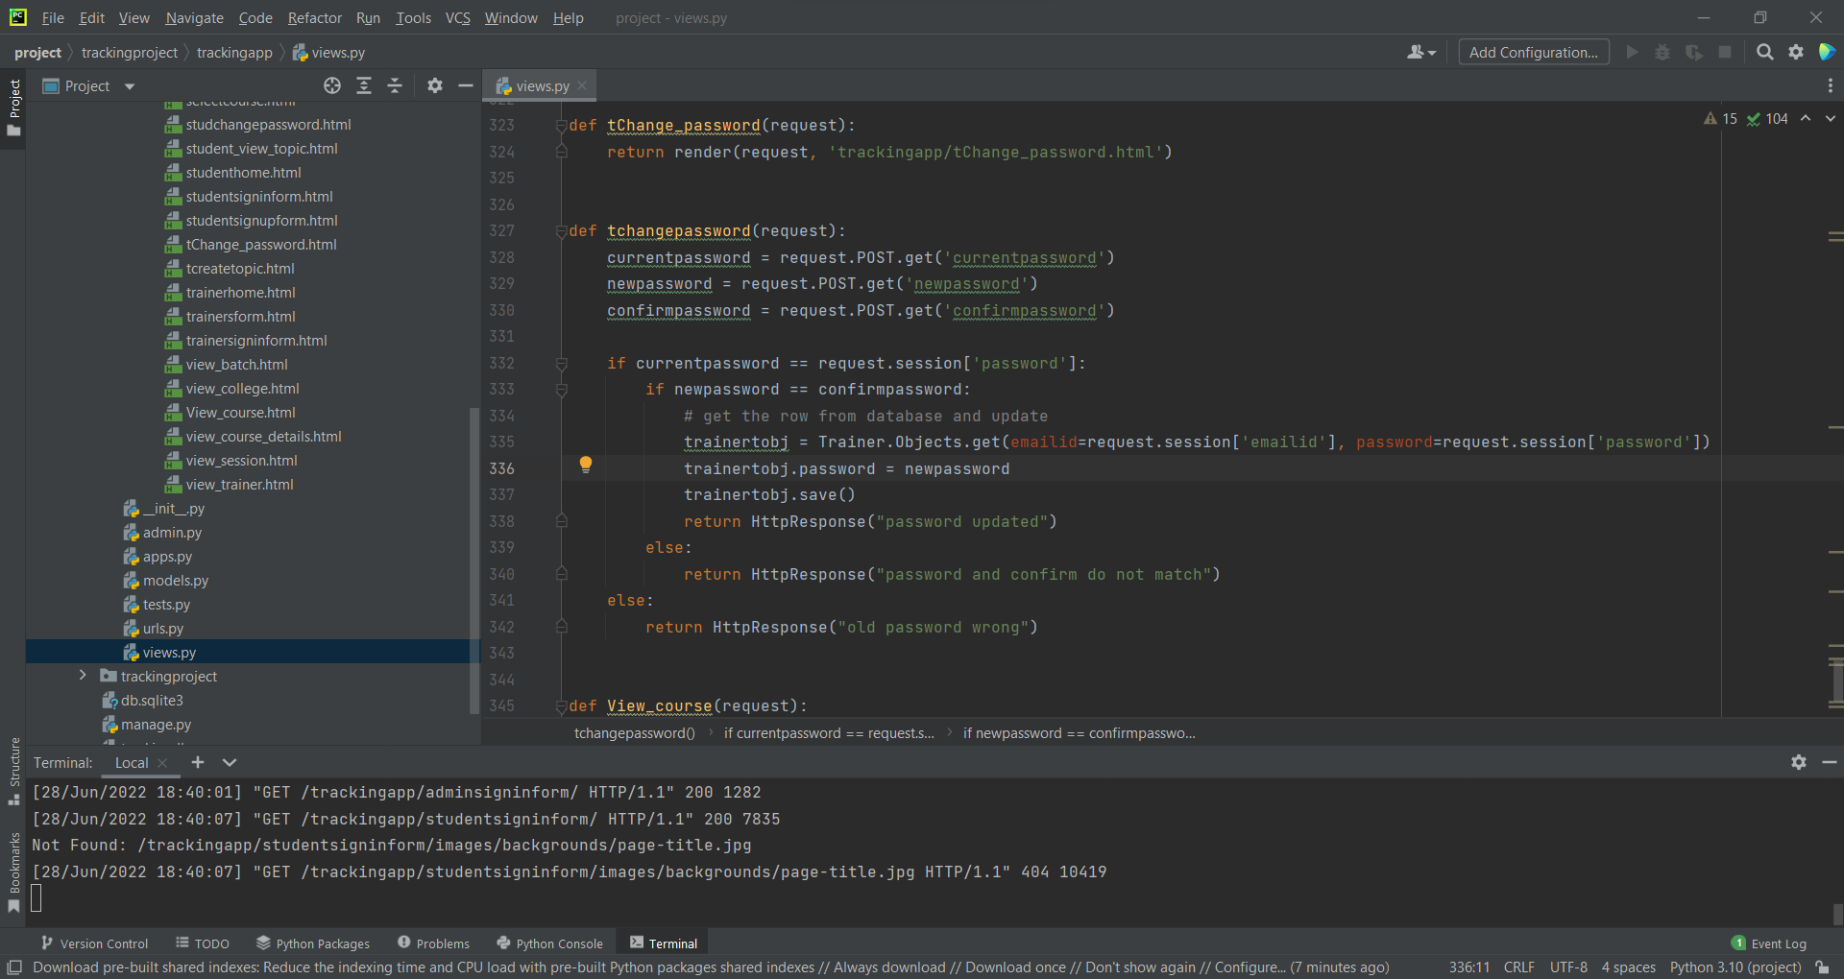

urls.py

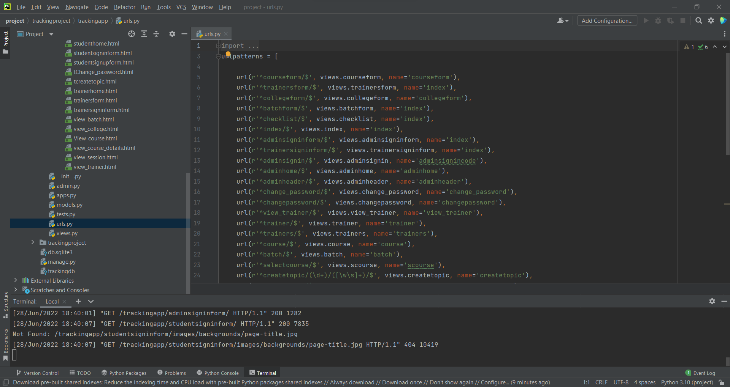

Models.py

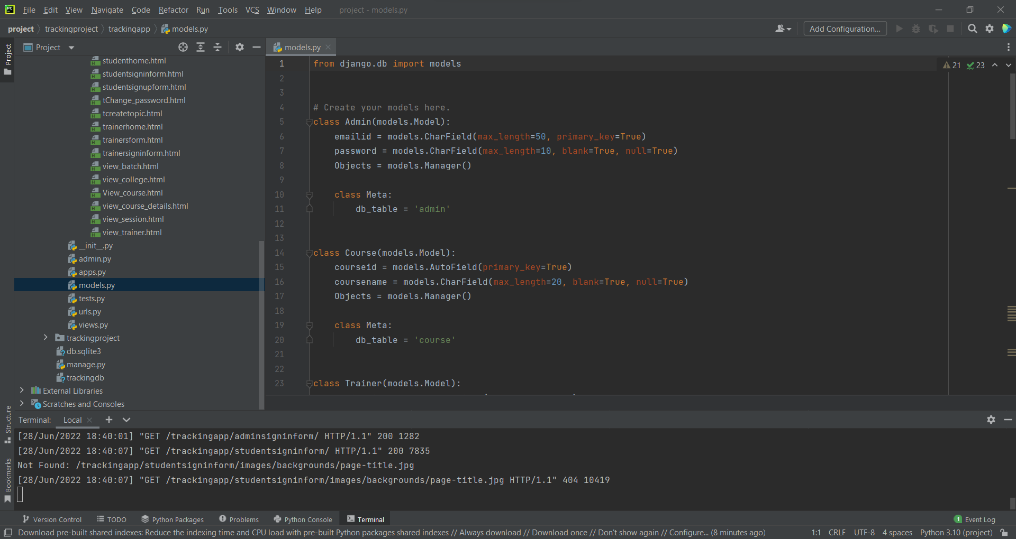

**CHAPTER 6**

**IMPLEMENTATION**

**6.1 SCREEN SHORTS**

ProjectHomescreenshort 

Fig 6.1.1

This is our project home page consistenting of the login home and contact us button

Adminlogin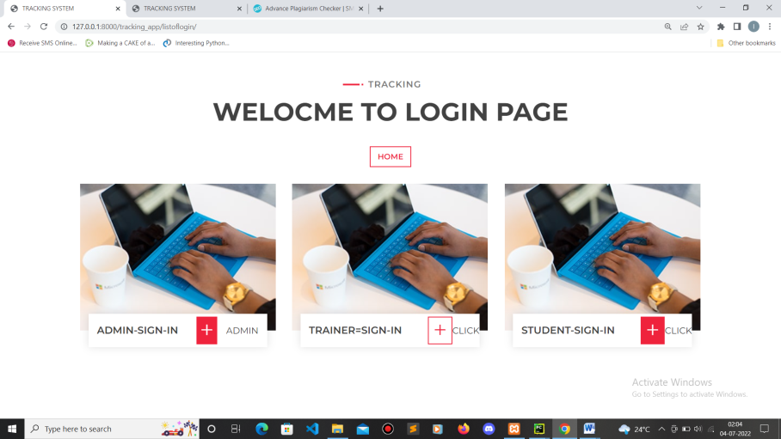 Fig 6.1.2

1.login for the admin – which is having the full authority for example like view the data of the trainer as well as the students ,creating the batch for the particular trainer and students

Admin-Header

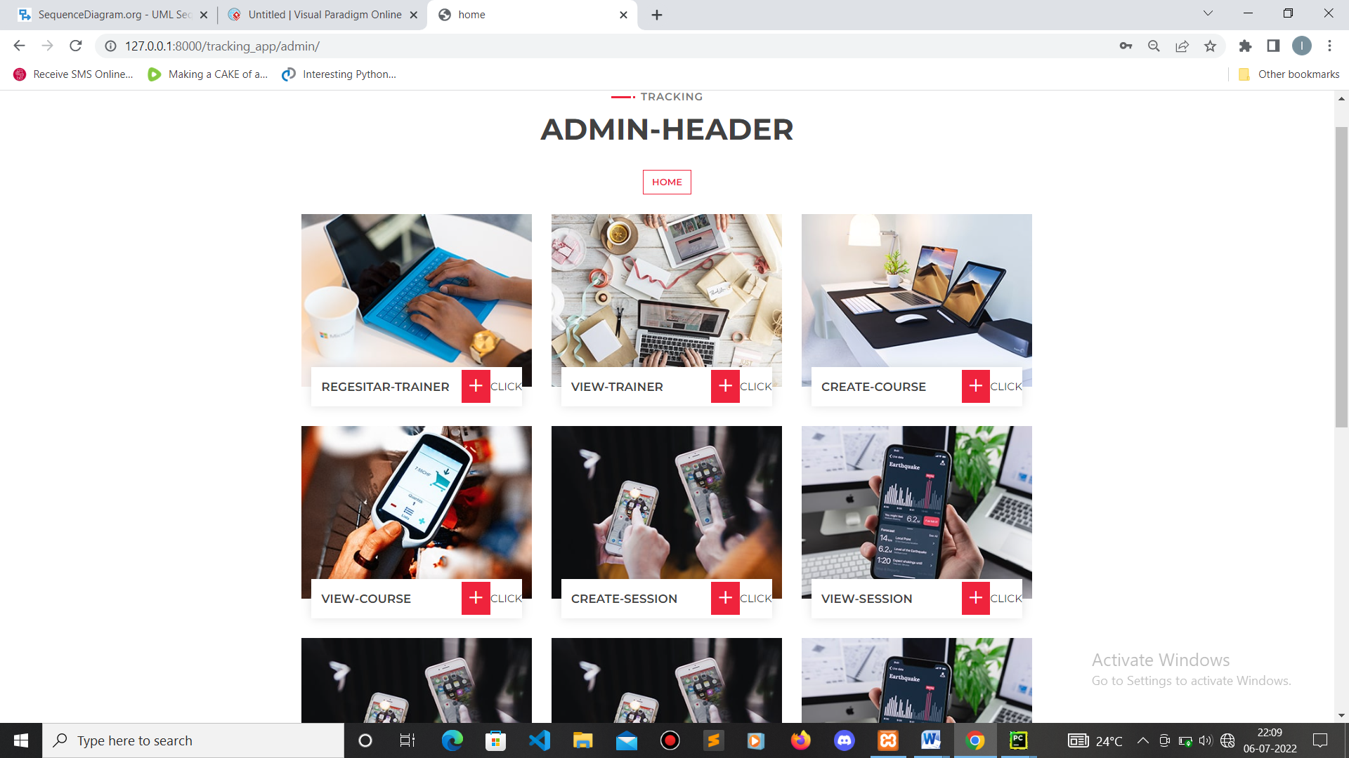

Fig 6.1.3

In admin we can see that there are many options for the admin to assign the works

Trainerqrcodegenrater

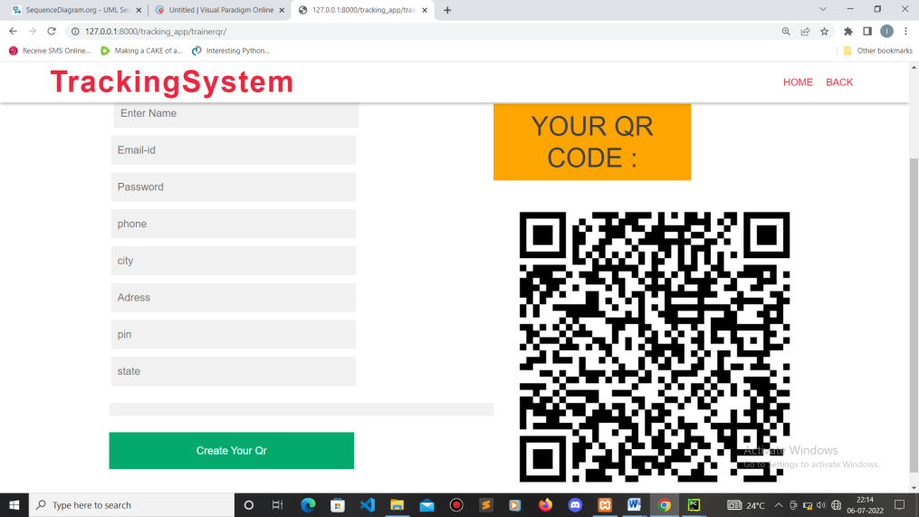

Fig 6.1.4

trainer-sign-whenever the trainer sign in the trainer directly send into trainer header form in which trainer can perform the multiple task such as he can change the password as well as he can give the attendance of the particular student who were attended to the particular class .So there are many more options are presents like creating session, selecting the topics, creating the batch these are all handled by the main admin And also very important part so creating qr code which used in future reference for attendance perspective

CHAPTER7

**Software testing**

7.1 Test Case

Admin module

|  |  |  |  |  |  |
| --- | --- | --- | --- | --- | --- |
| Sl no | Test case | Input | Excepted result | Actual result | pass |
| 1 | login | Login with vaild maild_id and password | Login successful | Login successful | yes |
| 2 |  | In valid mail-id | Incorrect user name | Incorrect user name | yes |
| 3 |  | Invalid password | Entre correct password | Entre correct password | yes |

Trainer module

|  |  |  |  |  |  |
| --- | --- | --- | --- | --- | --- |
| Sl no | Test case | Input | Excepted result | Actual result | pass |
| 1 | login | Login with vaild maild_id and pass | Login successful | Login successful | yes |
| 2 |  | Login with invalid mail_id | Incorrect user name | Incorrect user name | yes |
| 3 |  | Invalid password | Entre correct password | Entre correct password | yes |

Student module

|  |  |  |  |  |  |
| --- | --- | --- | --- | --- | --- |
| Sl no | Test case | Input | Excepted result | Actual result | pass |
| 1 | Sign_up | Register with correct information | Register sucssfull | Register sucssfull | yes |
| 2 | login | Login with vaild maild_id and password | Login successful | Login successful | yes |
| 3 |  | Login with invalid mail_id | Incorrect user name | Incorrect user name | yes |
| 4 |  | Invalid password | Entre correct password | Entre correct password | yes |

**CHAPTER 8**

**CONCLUSION**

Studies have been conducted on electronic learning , blending learning and face to face courses in order to determine which format is most effective . for example ,learning outcome and student satisfaction have been compared between different formats. As learning and teaching are complex processes, this literature review focuses on factors affecting student learning experiences in online learning. Blending learning and professional education. Among the setting ,student presence is important , as well as interaction between students and teachers interactions is important .Researches have found that a number of factors influence students learning expression. According to the literatre experience and review, factors that are especially important for professional education student learning experience and their learning identities are the availability of appropriate teaching.

**CHATER 9**

**Feature enhancement**

The project registration and tracking system which is used for track the student and trainer activities though the software so for this project they are mainly using the manual work to overcome the manual work this software is made because it automate the work in a very simpler manner .

So for the future enhancement we have made the

1.qr code scanner attendance

2.face recognition

3.mobile application

Chapter 10

**Appendix A**

**BIBLOGRAPHY**

**Reference Books**

* **Django for beginners**
* **A Wedge of Django**
* **Build a Website With Django 3**
* **W.jasonGlimor—Beginning PHP And MYSQL**

**SITE**

* [**www.w3school.com/**](http://www.w3school.com/)
* [**www.sitepoint.com/article/**](http://www.sitepoint.com/article/)
* [**http://stackoverflow.com/**](http://stackoverflow.com/)

**Appendix B**

**USER MANUAL**

**Step1:** open the website login

**Step2**: after login register the collage campus

**Step3**: create a session topic for the particular course

**Step4**: a particular batch is created

**Step5**: assign trainer to the batch

**Step6**: add students to the batch

**Step7**:give the attendance to students.

**Step8**:logout